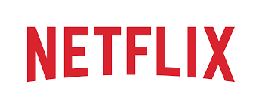

**Product Dissection for Netflix**

### **Company Overview:**

Netflix, founded in 1997 by Reed Hastings and Marc Randolph, has revolutionized the way people consume television and film content. It's a leading subscription-based streaming platform, known for its extensive library of shows, movies, and original content, such as "Stranger Things" and "The Crown." With a global presence and a commitment to innovation, Netflix has become a dominant force in the entertainment industry, reshaping how audiences experience entertainment.

### **Product Dissection and Real-World Problems Solved by Netflix:**

Product Dissection and Real-World Problems Solved by Netflix:

Netflix, a global streaming giant, has made significant contributions to addressing real-world challenges through its innovative product offerings. With a focus on on-demand, internet-based entertainment, Netflix has reshaped how people consume television and film content, providing solutions to various issues related to traditional media consumption.

**1.Content Accessibility and Choice**: Netflix addresses the problem of limited content accessibility and choice. In the past, viewers were often restricted to a fixed schedule of TV broadcasts and limited movie theaters. Netflix's vast library of movies, TV shows, and documentaries, available at any time and on multiple devices, empowers users to choose what they want to watch, when they want to watch it. This has revolutionized how people access entertainment, particularly in an era of busy schedules.

**2.Content Discovery and Personalization:** Netflix's recommendation options, personalized user profiles, and content duration features have tackled the challenge of content discovery. By analyzing user preferences and viewing history, Netflix suggests content that aligns with individual tastes. This personalized approach helps users navigate the vast amount of available content, making it easier to find shows and movies that match their interests.

**3.Original Content Production:** Netflix has also addressed the issue of creative content production. By investing heavily in original programming like "Stranger Things," "House of Cards," and "The Crown," Netflix has created a platform for unique storytelling and provided opportunities for diverse voices in the entertainment industry. This not only solves the problem of content diversity but also supports emerging talent.

**4.Global Accessibility:** Netflix's global expansion has bridged geographical boundaries. It has made high-quality content accessible to a worldwide audience, transcending language barriers and promoting cultural exchange. This addresses the need for global connectivity and cultural exposure.

**5.Flexible Subscription Models:** Netflix offers various subscription plans to cater to different budgets and preferences. This flexibility allows users to choose a plan that suits their needs, addressing issues of affordability and providing options for users with varying levels of engagement.

In summary, Netflix's product design has effectively addressed real-world challenges related to content accessibility, discovery, diversity, and global connectivity. By providing an on-demand streaming platform with personalized recommendations and a vast library of content, Netflix has transformed the entertainment industry and made significant contributions to how people experience television and film in the digital age.

### **Case Study: Real-World Problems and Netflix Innovative Solutions**

**Case Study: Real-World Problems and Netflix's Innovative Solutions.**

Netflix, a prominent streaming service, has not only transformed the entertainment industry but has also tackled significant real-world challenges through its innovative approach to content delivery. By understanding user needs and leveraging technology, Netflix has emerged as a solution-driven platform that addresses various issues related to traditional media consumption.

**Problem 1: Limited Content Access and Scheduling**

**Real-World Challenge:** Traditional TV schedules and limited access to content have long been a source of frustration for viewers. People often found it challenging to watch their favorite shows and movies on a fixed schedule or had limited access to content due to geographical constraints.

**Netflix's Solution:**

Netflix recognized the need for flexible and accessible content consumption. The platform offers a vast library of movies, TV series, and documentaries that users can stream on-demand. This model eliminates the need for scheduled programming, allowing users to watch what they want, when they want. Netflix's extensive global reach ensures that content is accessible to viewers worldwide, overcoming geographical limitations and making entertainment available to diverse audiences.

**Problem 2: Content Discovery and Personalization**

**Real-World Challenge:** With an overwhelming amount of content available, it can be challenging for viewers to discover new shows and movies that align with their interests. Traditional media platforms often lacked effective content recommendation systems.

**Netflix's Solution:**

Netflix addresses the problem of content discovery through its sophisticated recommendation algorithms. By analyzing user preferences, viewing history, and interactions, Netflix suggests content tailored to each user's tastes. This personalized approach enhances content discovery, making it easier for users to find and enjoy content that resonates with them, ultimately improving the overall viewing experience.

**Problem 3: Diversity and Inclusion in Entertainment**

**Real-World Challenge:** The entertainment industry has historically faced issues related to diversity and representation. Underrepresented voices and perspectives struggled to find a platform for their stories and experiences.

**Netflix's Solution:**

Netflix has championed diversity and inclusion in entertainment through its commitment to producing and promoting diverse content. The platform has invested in original programming that showcases a wide range of voices and cultures. By supporting and funding content creators from various backgrounds, Netflix has become a platform where diverse stories can thrive, solving the challenge of representation in the media landscape.

**Problem 4: The Cost of Entertainment**

**Real-World Challenge:** The cost of accessing a wide range of entertainment options, including movies and TV shows, through traditional cable subscriptions or theater tickets, could be prohibitive for many individuals and families.

**Netflix's Solution:**

Netflix offers various subscription plans with different price points, allowing users to choose a plan that suits their budget. This flexibility provides affordable access to a diverse library of content, making high-quality entertainment more accessible and cost-effective for a broad audience.

**Conclusion:**

Netflix's ability to address real-world challenges related to content access, discovery, diversity, and affordability has positioned it as a pioneering force in the entertainment industry. By offering a user-centric platform with personalized content recommendations, promoting diversity in content creation, and providing flexible pricing options, Netflix has redefined how people consume and enjoy entertainment. This case study highlights how Netflix's innovation and commitment to meeting user needs have made it a global leader in the streaming media landscape, reshaping the way we experience television and film.

### **Top Features of Instagram:**

**1**. **Personalized Profiles:** Netflix offers a user-centric experience with personalized profiles. Each user can create their own profile with a unique name and avatar, allowing for tailored content recommendations and individualized viewing histories.

**2.Vast Content Library:** Netflix provides an extensive library of movies, TV series, documentaries, and original content. Users have access to a wide range of genres and languages, ensuring there's something for everyone.

**3.Content Discovery:** Netflix addresses the challenge of content discovery with its recommendation algorithms. By analyzing user preferences and viewing habits, Netflix suggests content that aligns with each viewer's interests, making it easier to discover new shows and movies.

**4.On-Demand Streaming:** Netflix revolutionizes how users watch content by offering on-demand streaming. There are no fixed schedules or commercials, allowing users to watch their favorite shows and movies at their convenience.

**5.Offline Viewing:** The platform enables users to download selected titles for offline viewing. This feature is particularly useful for users who may not always have an internet connection but still want to enjoy their favorite content.

**6.Multiple Devices:** Netflix is accessible on a variety of devices, including smartphones, tablets, smart TVs, and gaming consoles. This multi-platform approach ensures that users can watch Netflix wherever and whenever they want.

**7.Original Content:** Netflix has made a significant mark in the entertainment industry by producing high-quality original content. Hit series like "Stranger Things" and "The Crown" have become cultural phenomena, and Netflix continues to invest in unique storytelling.

**8.Global Accessibility:** Netflix's global reach ensures that it is available in nearly every country, transcending geographical boundaries and making it a global platform for entertainment.

**9.Flexible Subscription Plans:** Netflix offers different subscription tiers, allowing users to choose plans that fit their budget and viewing preferences. This flexibility ensures that users can access Netflix content at a price point that suits them.

**10.User Profiles and Parental Controls:** Within each account, users can set up multiple profiles for family members with age-appropriate content restrictions. This ensures a family-friendly viewing experience and allows parents to have control over what their children can access.

In summary, Netflix's top features include a vast content library, personalized profiles, advanced content discovery, on-demand streaming, offline viewing, multi-device accessibility, original content production, global accessibility, flexible subscription plans, and user profile and parental control options. These features collectively contribute to Netflix's status as a leading streaming platform that offers a user-friendly and tailored entertainment experience.

### **Schema Description:**

**Schema Description for Netflix:**

The schema for Netflix involves multiple entities that represent different aspects of the streaming platform. These entities include Users, Profiles, Titles, Genres, Viewing History, and more. Each entity has specific attributes that describe its properties and relationships with other entities.

**User Entity:**

Users are the primary consumers of content on Netflix. The user entity contains information about each user:

* **UserID (Primary Key):** A unique identifier for each user.
* **Username:** The chosen username or account identifier for the user.
* **Email:** The user's email address for account-related communication.
* **Password:** Encrypted user password for account security.
* **Payment_Info:** Payment details for subscription billing.
* **Subscription_Type:** The type of subscription (e.g., Standard, Premium) chosen by the user.

**Profile Entity:**

Netflix allows multiple user profiles under a single account for personalized recommendations and viewing histories. Each profile has its settings and preferences:

* **ProfileID (Primary Key)**: A unique identifier for each user profile.
* **UserID (Foreign Key referencing User Entity):** The user to whom the profile belongs.
* **Profile_Name:** The name or identifier for the profile (e.g., "John's Profile").
* **Preferred_Language:** The language preference for content.

**Viewing History Entity:**

Viewing history records the titles watched by users on their profiles:

* **ViewingID (Primary Key):** A unique identifier for each viewing history entry.
* **ProfileID (Foreign Key referencing Profile Entity):** The profile associated with the viewing history.
* **TitleID (Foreign Key referencing Title Entity):** The title watched by the user.
* **Date_Watched:** The date when the title was watched.

**Title Entity:**

Titles represent the movies, TV series, and other content available on Netflix:

* **TitleID (Primary Key):** A unique identifier for each title.
* **Title_Name:** The title's name or identifier (e.g., "Stranger Things").
* **Release_Date:** The date when the title was released.
* **Description:** A brief summary or description of the title.

**Genre Entity:**

Genres categorize content to help users discover titles of interest:

* **GenreID (Primary Key):** A unique identifier for each genre.
* **Genre_Name:**The name of the genre (e.g., "Action," "Comedy").

**TitleGenre Entity:**

Associates titles with genres:

**TitleGenreID (Primary Key):** A unique identifier for each association.

**TitleID (Foreign Key referencing Title Entity):** The title associated with the genre.

**GenreID (Foreign Key referencing Genre Entity):** The genre associated with the title.

**Relationships:**

Users have Profiles – Each user can have multiple profiles under their account.

Profiles have Viewing History – Each profile has a history of titles watched.

Titles have Genres – Each title belongs to one or more genres.

Profiles have Preferences – Each profile can have language and content preferences.

Profiles can have Viewing Histories – Each profile has a history of titles watched.

In summary, Netflix's schema revolves around users, their profiles, viewing histories, and the titles available on the platform. Genres help categorize content, and associations between titles and genres aid in content discovery. This schema enables Netflix to provide a personalized and seamless streaming experience for its users.

**ER Diagram:**

Let's construct an ER diagram that vividly portrays the relationships and attributes of the entities within the Netflix schema. This ER diagram will serve as a visual representation, shedding light on the pivotal components of Netflix's data model. By employing this diagram, you'll gain a clearer grasp of the intricate interactions and connections that define the platform's dynamics.

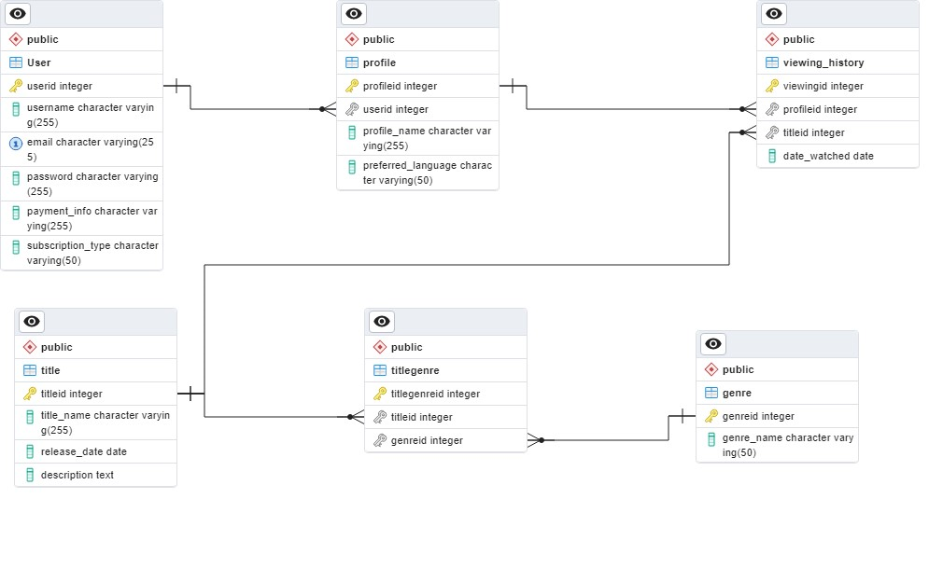

### **Conclusion**

In this case study, we've delved into the database schema and Entity-Relationship diagram of Netflix, a powerhouse in the world of streaming entertainment. Netflix has reshaped how we consume content, offering an extensive array of movies, TV shows, and documentaries, all tailored to individual preferences. The schema, comprising user-related entities, viewing history, title, genre, and titlegenre, is the backbone of Netflix's personalized content delivery and recommendation system. Understanding this schema provides insights into how Netflix efficiently manages its vast content library and caters to the diverse tastes of its global audience. Netflix's database design is at the heart of its ability to provide a satisfying and engaging streaming experience, making it a trailblazer in the digital entertainment industry.

**VideoPresentationLink**:

https://drive.google.com/file/d/1iw9A93vu4FzQjFiZXx1K6YxVTsX9EPmF/view?usp=drive_link